Project Design Phase
Problem – Solution Fit Template

Date | 02 November 2025
Team ID | NM2025TMID00562
Project Name | Laptop Request Catalog Item
Maximum Marks | 2 Marks

Problem – Solution Fit Template
The Problem–Solution Fit refers to identifying a real challenge faced by employees and IT staff in managing laptop requests, and developing a ServiceNow-based solution that actually resolves these issues effectively.
It ensures that the digital workflow aligns with user needs, improving communication, efficiency, and satisfaction within the organization.

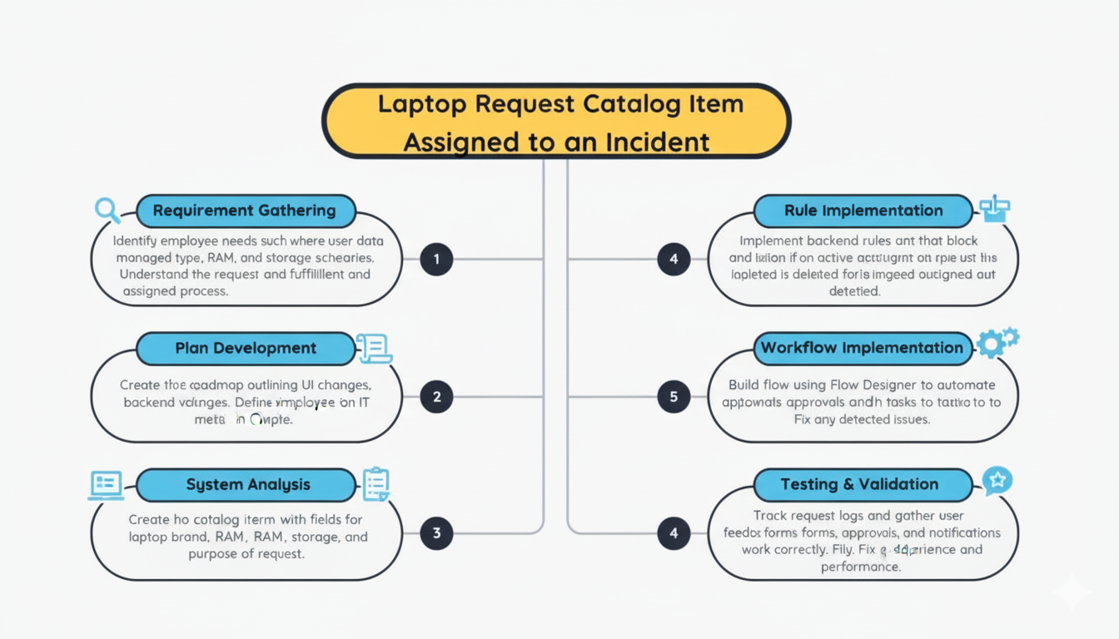
Purpose

- Solve practical workflow issues by automating the laptop request and approval process in a way that fits employees’ real needs and work culture.
- Speed up request handling and increase system adoption by providing an easy, centralized platform accessible to all employees and managers.
- Enhance clarity and accountability through real-time status tracking, automated notifications, and transparent approvals.
- Build user trust by minimizing manual delays, lost requests, and repetitive communication between employees, managers, and IT staff.
- Understand and improve existing request methods to make them more efficient, reliable, and user-friendly through digital transformation with ServiceNow.

